***UNLOCKING A RESESILEINT FUTURE! Education Sector***

Computer Application Technology

As education sector many schools and universities had suffered because of corona virus (Covid 19). The all implemented certain strategies that helps them to carry on learning even though there was an issue o covid 19. It helped all those all under education sector and learning successful go on.

Mashoba Mukelani

wiggins seondary school

## Table of Contents

Contents

**Table of Contents** 2

**Table of figures** 3

***Introduction*** 4

***Task Definition*** 5

***Focus Question*** 6

**Findings** 7

***Learners*** 7

**Teachers** 7

**Discussions and Analysis** 8

**conclusion** 10

**Bibliography** 12

**Appendices** 13

**Addendum** 14

**Website sources** 15

## Table of figures

**Figure 1**: image 1 Covid-19-report-web report web on page 26 4

**Figure 2**:Females and Males participated in the survey 8

**Figure 3**:Females and Males using WhatsApp 8

**Figure 4** : Online collaborations used by females and males 9

**Figure 5:** Females and Makes using Skype 9

**Figure 6**: Females and Males using Zoom 9

## ***Introduction***

In an attempt to contain the spread of COVID-19, in the large majority of countries around the educational institutions have decided to temporarily suspend in-person instruction and move to a remote learning model of delivery (Costa.P, 2020).

According to UNESCO, on the 27 of March 2020, educational institutions shut down in South Africa, affecting about 74% of total learners on the country. Schools have been closed since the beginning of March 2020 in other countries.

Several countries (e.g. Malta, Portugal, Ireland) have announced that (parts of) the formal education system will not re-open this academic year, whereas in others (parts of) the formal education system have progressively re-opened in April/May to facilitate assessment and certification, depending on medical advice.

What is likely to be the effect of the long school closure caused by COVID-19 on children’s learning in the short-term? Will this crisis have any impact also in the long-term? While the current situation makes it difficult to predict the effect that it will have on student achievement, a useful exercise is to look at the economics in an attempt to gain a better understanding of how the virus and physical school closure may impact education and learning. Such analysis is complemented and supplemented by recent relevant statistical information.

Data from various sources are used. This report does not focus on a specific educational level or students’ age group. However as will be indicated in the text, are relevant (or more relevant) for a given level. Additionally, it has been impossible to present evidence related to students from different age groups as only students of a specific grade/age are typically considered in the international datasets mentioned above.

Our reflections may assist policymakers in formulating interventions and strategies to address the consequences of the crisis. Indeed, they may also assist teachers and parents in how to best support students during and after this emergency period. The remainder of the report is as follows. We will look at student learning, highlighting the important role of remote schooling in these circumstances, implications of the COVID-19 crisis for educational inequality, summaries the main findings of the report and the negative effects that COVID-19 is having on education.

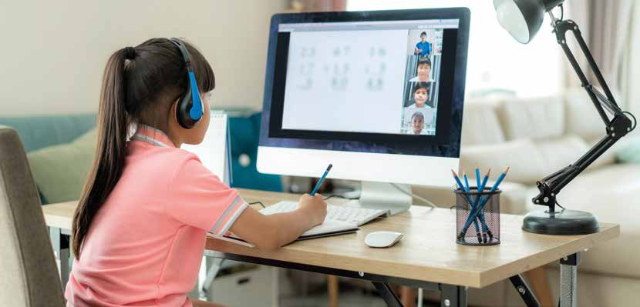

Figure : image 1 Covid-19-report-web report web on page 26

## ***Task Definition***

The current situation we were facing as a country is the **coronavirus** which made lot of education sectors to close down and others to try implement new strategies on how the learning process will carry on and this mostly affected those who are doing matric and those who are in tertiary which are the universities. This has become a big problem to the education sector and other sectors. This was the unexpected to happen. ***COVID 19*** started spreading by the late **2019 into 2021**

For this investigation that I was doing I will be focused mainly on education sector which includes (schools, universities, colleges, learning resources). The main purpose for the investigation was to gather information on how the education sector is coping with this situation which is corona virus and what they did to prevent the spread of this virus. And on how the manage to continue with learning process as said before.

***To get all the information*** I need I went and done a lot of research on internet and do many interviews with learners, students, principles and others to help me. By that I used **Spreadshee**t to process data, use queries and reports that will be found in database (**report**s and **queries**). Even website’s is used to show all the information that will be gathered throughout the investigation, the collection of data and information has shown. Also **questionnaires** will be used for asking and doing interviews

For the investigation the **target audience** were mainly the learners, students and those who fall under education sector it helped them to know more about what is happening in education sector during this time of **coronavirus.**

## ***Focus Question***

* How does the government help education sectors prevent **Covid 19**?

Government try by all means to help education sectors to prevent Covid 19 that why the government implement Covid 19 protocols which helps mostly at schools, universities, colleges and others who are under education sector.

Education sector depend on government and all the help is from the government. The government has announced the changes that education sector like schools the must be a certain number of students attending at school, not all learners are able to go to school but they Are given certain dates and days that they are going to be attending on.

## **Findings**

Online Classes are challenging for learners or students and teachers

# **Learners**

* As I was doing the investigation, I found out that many learners are not coping or able to adjust with what happening based on online learning for others it difficult to carry on learning online.
* The reason for some learners is that they have poor internet connection which is a big problem because the fall behind on the session or the day.
* But as for other learners it is easy and find it helping a lot when comes to learning and they are able happy with online learning.
* The students that are in university and colleges confirmed that it is easy for them to study or learn online because they have experience and they know does online learning works.

**Problem faced by learners in rural areas**

* Constant power cut
* Lack of internet facilities
* Technical problems

**Home learning environment**

* In addition to having access to appropriate digital resources, students need to be in a home environment that is conducive to learning. However, this might not be the case for a large number of students from less advantaged families, who often have to do their work in a small space shared with other family members.
* Disadvantaged students are found to be more likely to attend schools with lower ICT resources

# **Teachers**

* Teachers are not finding online learning for them challenging at all but problems they are facing is:
* Learning don’t attend online classes.
* Hard to explain.
* Not all learners are able to attend online classes because of some other reasons.
* Lack of appropriate materials and resources.

**Solutions**

* Announcing free live classes on its Think and Learn app.
* Teachers in private schools had set work via an online learning platform already on Monday, Tuesday, and Friday to all learners who cannot have access to online learning and who find it difficult to learn online.
* Students has agreed to attend in school by groups and which make it able and easy to carry on with learning.
* Having a home base for important information is critical during distance learning
* Manage their time, plan how they will use their time.
* Teachers can record videos of a lesson and then send to all the learners.
* In rural or remote areas students will be provided with support documents and resources tom use and learn with them.

## **Discussions and Analysis**

**Link to find original graphs** : ..\Phase 2\Spreadsheet Data.xlsx

5 Different types of graphs

**Figure 2**:People participated in the survey

**Figure 3**:Females and Males using WhatsApp

**Figure 4** : Online collaborations used by females and males

**Figure 5:** Females and Makes using Skype

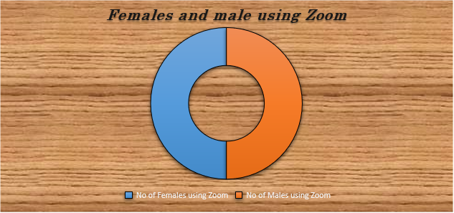

**Figure 6**: Females and Males using Zoom

## **conclusion**

The education sector has tried and adapted numerous ways to make learning possible.

Through asking varies questions I’ve collected information that state and prove. I was able to find data on how the education sector has adapted by doing things differently than before Online classes has shown to be challenging for a majority of students. The most of the students I asked and interviewed do agree that government helps education sector in so many different ways and they are able to implement that changes that are needed to be made as requested by the government.

Most educational institutions around the world cancelled in-person instruction and moved

to remote learning and teaching in March 2020 in an attempt to contain the spread of

COVID-19. Parts of the (or the whole) formal education system will not re-open this

academic year in some countries, whereas in others (parts of) the formal education system

have progressively re-opened.

While the disruption in learning caused by COVID-19 is unprecedented, important insights

about its possible impact can be gained from findings of relevant existing studies and COVID-19 data.

Although the adoption of distance learning is key to ensure the continuity of education

following the physical closure of schools, students are, on average, likely to experience a

learning loss during the lockdown. Several arguments can be put forward to explain this

## **Bibliography**

British, P. o. (2020, March 15). *E-Learning Africa.* Retrieved from The effect of covid 19 on education Africa: http://www.the effects of covid 19 on education Africa.com

Costa.P. (2020). The likely impact of COVID-19 on education. *Schools*, 1.

D, B. (2020, MARCH 29). *Online Collaboration tools.* Retrieved from Commnication and online meetings: http://.online collboration tools.com

Dowson, T. (2021). The Challenges of online learning. *The COVID-19 pandemic has changed education forever*, 1.

Mtshali, N. (2020, July 14). *Google Chrome*. Retrieved from Google.com: https://theconversation.com/covid-19-school-closures-in-south-africa-and-thier-impact-on-children-141832.com

Ncube, N. (2021, March 28). Solutions that will be applied to countinue learning. (M.Mashoba, Interviewer)

Shangase, M. (2021, March 16). What is done to prevent the spread of Covid 19 at schools. (M. Mashoba, Interviewer)

Syed, M. (2020). *Impact of COVID 19 on Education on high institution.* London: Edge Foundation.

## **Appendices**

Structure folder

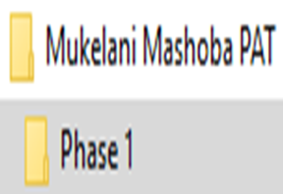

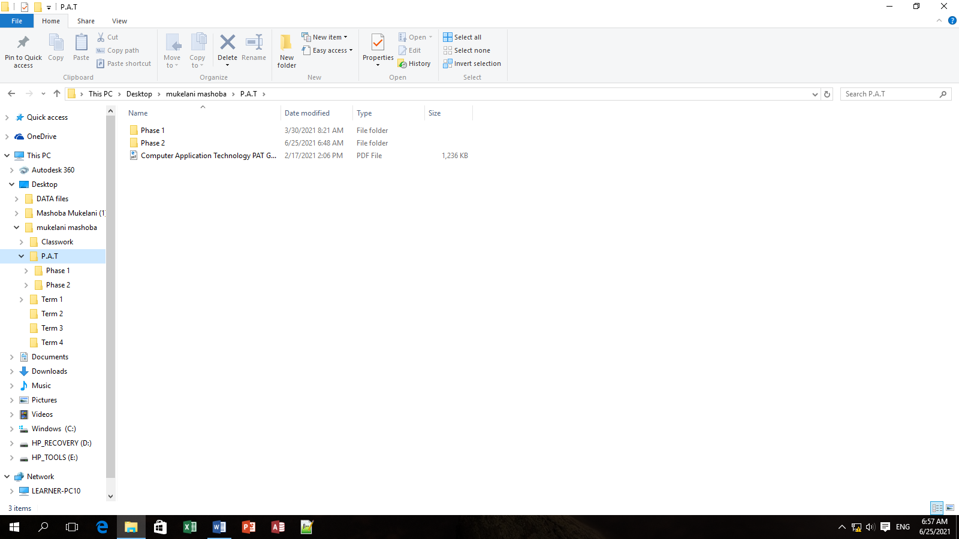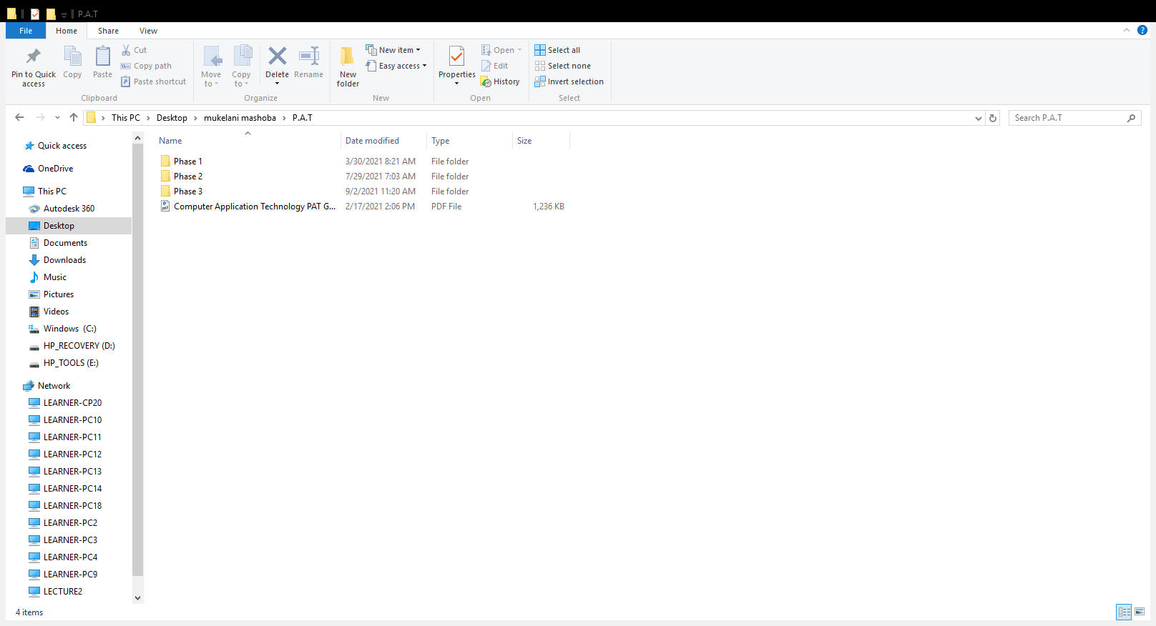

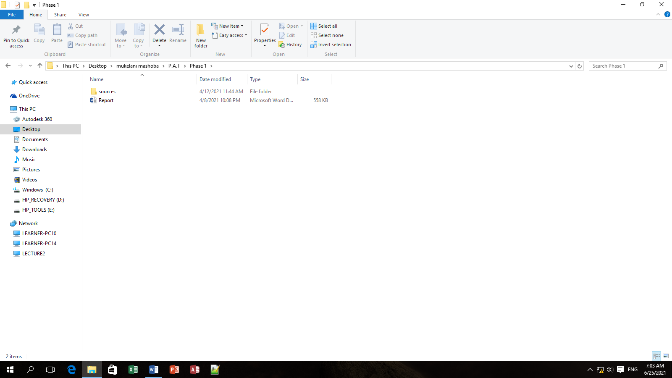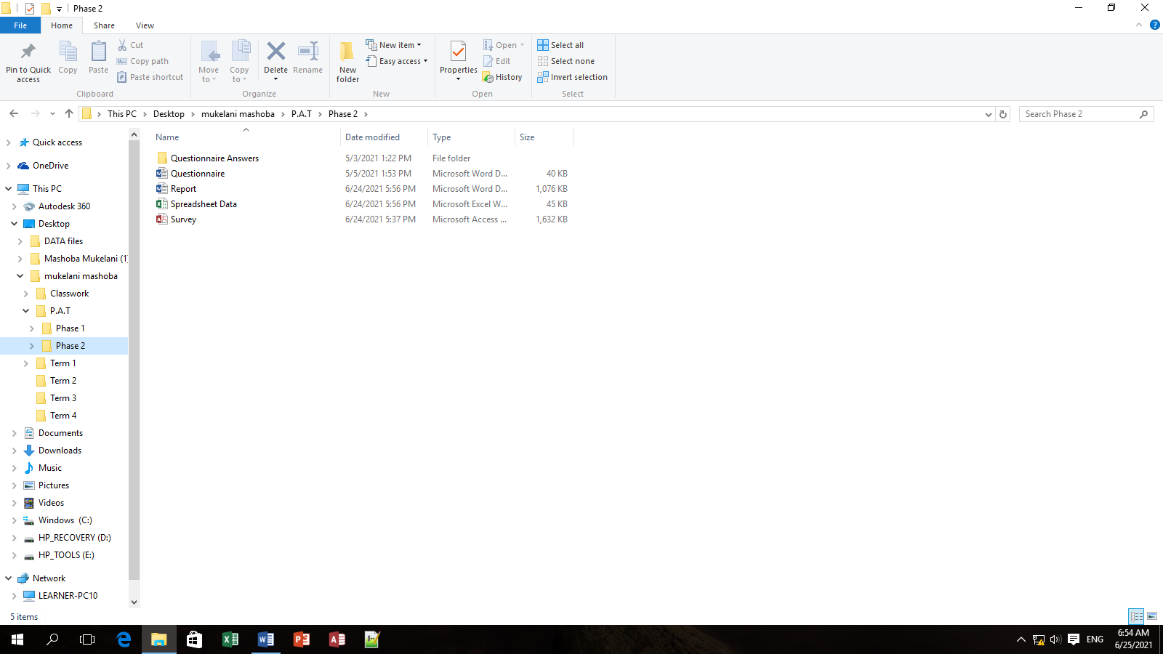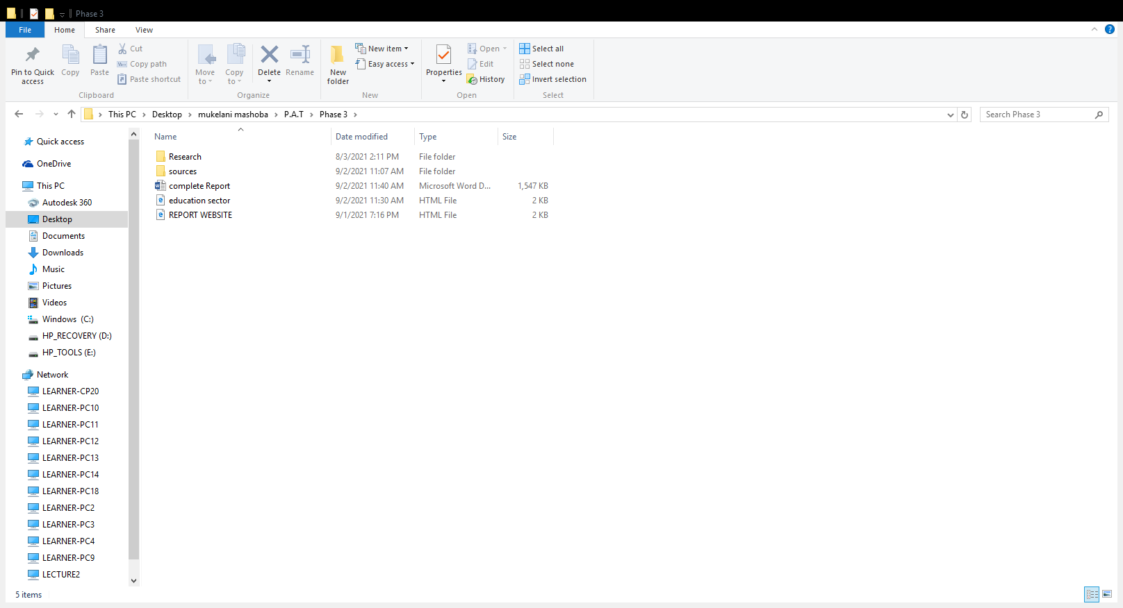

Report

Website

Questionnaire

Database

Sources

Report

Spreadsheet

Phase 1

Phase 3

Phase 2

Mukelani Mashoba Grade 12” A”

## **Addendum**

|  |  |  |  |  |  |  |  |
| --- | --- | --- | --- | --- | --- | --- | --- |
| *No.* | Question | Question level | Category | Type of source | Bibliographical Information | Quantity of information found | Summary of information found |
| *1.* | What is mostly done to prevent the spread of Covid 19 in schools? | 1 | Solution | interview | (Shangase, 2021) | Accuracy | * sources\What is mostly done to prevent the spread of Covid 19 in schools.docx |
| *2.* | How does the government help in education sector during corona virus? | 2 | Costs | Pdf Document | (Mtshali, 2020) | Accuracy | * sources\How does the government help in education sector during corona virus.docx |
| *3.* | What solutions could be implemented to continue assist in distance learning for colleges and universities? | 4 | Solution | Report | (Syed, 2020) | Accuracy | * sources\What’s solutions could be applied to continue learning for colleges and universities.docx |
| *4.* | How can government get involved to address the challenges that prevent learners from accessing online learning ? | 1 | Solution | Internet | (British, 2020) | Authority | * sources\How can businesses get involved to address the challenges that prevent learners from accessing online learning.docx |
| *5.* | How has this affected the way schools operate? | 2 | Impact | Report | (Syed, 2020) | Coverage | * sources\How has this affected the way schools operate.docx |
| *6.* | Have online learning helped learners to catch up on their school work ? | 1 | Background | Journal Article | (Dowson, 2021) | Currency | * sources\Have online learning helped learners to catch up on their school work.docx |
| *7.* | Which online collaboration tools in education sector are most used for online learning and communicating? | 1 | Background | Internet/website | (D, 2020) | Coverage | * sources\Which online collaboration tools in education sector are most used for online learning and communicating.docx |
| *8.* | Is it easy to assess online resources for students in remote areas ? | 4 | Problem | Interview | (Ncube, 2021) | Currency | * sources\It is easy to assess online resources for students in remote areas.docx |
| *9.* | What’s solutions could be applied to continue learning for schools ? | 1 | Solution | interview | (Ncube, 2021) | Authority | * sources\What’s solutions could be applied to continue learning for schools.docx |
| *10.* | What is done to help those learners who can’t have access on online learning ? | 1 | Solution | Journal article | (Dowson, 2021) | Accuracy | * sources\What’s is done to help those learners who can’t have access on online learning.docx |

## **Website sources**

|  |  |
| --- | --- |
| WEBSITE SOURCE 120 45856 | |
| **Author(s)/Publisher** | D, Berger |
| **Name of website/webpage** | Communication and online meetings |
| **Date updated** | 29 March 2020 |
| **Date Accessed** | 15 March 2021 |
| **URL** | http://. online collaboration tools.com |

|  |  |
| --- | --- |
| WEBSITE SOURCE | |
| **Author(s)/Publisher** | British People |
| **Name of website/webpage** | The effect of Covid 19 on education Africa |
| **Date updated** | 15 March 2020 |
| **Date Accessed** | 08 April 2021 |
| **URL** | http://www.the effects of Covid 19 on education Africa.com |

|  |  |
| --- | --- |
| **OTHER SOURCE** | |
| Interviewee | MR Shangase |
| Interviewer | Mukelani Mashoba |
| Question Asked | What is mostly done to prevent the spread of Covid 19 in schools? |
| Date of Interview | 2020/03/3 |